**Evaluation**

A screenshot of the confusion matrix can be seen below:

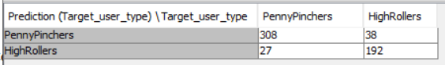

As seen in the screenshot above, the overall accuracy of the model is 88.5

308 PeenyPinchers correct predictions and 38 PennyPinchers incorrect prediction.

192 HighRollers correctly predicted and 27 HighRollers incorrect prediction.